COVER LETTER

Dear Editor-in-Chief
Squalen Bull.of Mar. & Fish.Postharvest & Biotech.,

I herewith enclosed a research article,

Title:
Microplastic Occurrence in Different Fish Organs from Two Coastal Waters in Java Sea, Indonesia

Author name:

Dwiyitno Dwiyitno*, Giri Rohmat Barokah, Izhamil Hidayah, Hedi Indra Januar, and Singgih Wibowo

Addresses
(Please provide current affiliation and address for all authors, including email addresses)

Dwiyitno Dwiyitno: Research Center for Food Technology and Processing, BRIN, Jl. Jogja-Wonosari KM 31.5, Gunungkidul 55681 (email: dwiy007@brin.go.id)

Giri Rohmat Barokah: Research Center for Food Technology and Processing, BRIN, Jl. Jogja-Wonosari KM 31.5, Gunungkidul 55681 (email: girir004@brin.go.id)
Izhamil Hidayah: Research Center for Ecology and Ethnobiology, BRIN, KST Soekarno, Cibinong 16911 (email: izha002@brin.go.id)
Hedi Indra Januar: Research Center for Ecology and Ethnobiology, BRIN, KST Soekarno, Cibinong 16911 (email: hedi.indra.januar@brin.go.id)
Singgih Wibowo: Research Center for Marine and Land Bioindustry, BRIN, Pemenang Barat, Mataram 83352 (email: paksingh@yahoo.com)

Word count (without references):
Please indicate your manuscript word count:
- Review article (6000-8000 words)
- Research article (4000-5000 words) | 4196
- Short communication (3000-4000 words)

Subject Area:
Please choose the most relevant subject area to your study:
- Marine and fisheries postharvest, preservation and processing, including mechanization engineering
- Fish and fishery products quality and safety | X
- Marine ecology and pollution related to fish and fishery products
- Biodiscovery/marine natural products
- Marine biotechnology and bioprocess engineering

Novelty:
(Please state your claimed novelty of the findings versus current knowledge)
- A comprehensive assessment on microplastic in different fish organs in Indonesia.
- The study revealed microplastic pollution in two essential coastal areas.
- Microplastic was found in all fish species samples from two essential coastal areas.
- The different microplastic sizes and shapes affected the accumulation pattern in fish organs.
- The different microplastic profiles indicated different plastic emissions in the study areas.

List of four potential reviewers
(Please fill in names of four potential reviewers and their email addresses. He/she should have Scopus ID and come from separate institutions from the authors)
Bintal Amin email: bintal.amin@lecturer.unri.ac.id Scopus ID: 0000-0003-3951-7042
Defri Yona email: defri.yona@ub.ac.id Scopus ID: 0000-0003-4266-9071
Yusli Wardiatno email: yusli@ipb.ac.id Scopus ID: 0000-0002-3680-3169
Noverita Dian Takarina email: noverita.dian@sci.ui.ac.id Scopus ID: 0000-0003-1766-7445

Place and date:
Bogor, 3 March 2024

Sincerely yours,
(fill in your name, no need scanned autograph)
Dwiyitno Dwiyitno

AUTHORS’ STATEMENT

Manuscript title :
Microplastic Occurrence in Different Fish Organs from Two Coastal Waters in Java Sea, Indonesia

We hereby declare that we agree to submit this manuscript to the Squalen Bulletin of Marine and Fisheries Postharvest and Biotechnology and, if accepted, to transfer the copyright of this article to this bulletin.
We confirm that this manuscript is original without fabrication and plagiarism. It has not been previously published or is being submitted for publication elsewhere.
We warrant that there is no conflict of interest with other people or organization that might be construed to influence the results or interpretation of this manuscript.
We confirm that each listed authors have made a substantial contribution to the manuscript and ensure nobody who qualifies for authorship has been excluded. Main Contributor(s) is(are) marked by an asterisk (*).




Author : Dwiyitno Dwiyitno* Signature

Author : Giri R. Barokah* Signature

Author : Izhamil Hidayah* Signature

Author : Hedi Indra Januar* Signature
Author : Singgih Wibowo* Signature

Microplastic Occurrence in Different Fish Organs
from Two Coastal Waters in Java Sea, Indonesia

Dwiyitno Dwiyitno^{1*}, Giri Rohmat Barokah¹, Izhamil Hidayah², Hedi Indra Januar², and Singgih Wibowo³

¹Research Center for Food Technology and Processing, BRIN, Jl. Jogja-Wonosari KM 31.5, Gunungkidul 55681, Indonesia
²Research Center for Ecology and Ethnobiology, BRIN, KST Soekarno, Cibinong 16911, Indonesia
³Research Center for Marine and Land Bioindustry, BRIN, Pemenang Barat, Mataram 83352, Indonesia

*Corresponding author: dwiy007@brin.go.id

Abstract
Plastic debris and microplastic have been associated with marine pollution. The present study aimed to assess the microplastic (MP) accumulation in different organs (gut and gill) of 6 fish species, provided from two essential coastal areas in Indonesia (Jakarta Bay and Cirebon Bay). The result showed that MP was found in all investigated economically important fish species. Generally, MP concentration in fish from Cirebon Bay was slightly higher than that from Jakarta Bay, with Siganus javus known as the most contaminated species in both locations. Microplastic was more concentrated on the gill of fish from Jakarta Bay, in contrast with that from Cirebon Bay. The predominantly MP in Jakarta Bay fish was fiber, while in Cirebon Bay was fragment with minor granule and film in both locations. Polyethylene (PE), polyvinyl chloride (PVC), and polypropylene (PP) were the most dominant MP in the fish samples from both study areas. Microplastic size showed that the majority (65%) was the small size (<1 mm), compared to the bigger one (1-5 mm), while blue, black, and red are the predominantly MP color in both locations. Due to instrument limitations, we could not investigate MP <100 µm, which may be present in the sample. It is suggested to compare MP profiles in fish samples and in water or sediment compartments.

Keywords: microplastic, fish gut, fish gill, Jakarta Bay, Cirebon Bay

Introduction
The population growth and economic development have led to an increasing solid and liquid waste emission in Indonesia, especially in big cities such as Jakarta and Surabaya (Cordova & Nurhati, 2019; Dwiyitno et al., 2016; Yona et al., 2019). Importantly, plastic pollution has been recognized as harmful and reported to expose a wide range of wild organisms, including seafood, marine mammals, birds, and other products related to marine sources such as sea salt (Devriese et al., 2017; Kim et al., 2018; Rochman et al., 2015). Other studies reported that Indonesian waters are contaminated by plastic debris (Cordova & Nurhati, 2019; Fitri & Patria, 2019; Jambeck et al., 2015; OECD, 2020; Yona et al., 2019).
Through the bio-magnification pathway via the aquatic food web, MP contaminants potentially accumulate in aquatic organisms, including seafood. Furthermore, MP has shown possible ecotoxicological effects on marine organisms, such as weight loss, reduced feeding rate, increased phagocytic activity, transferable to the lysosomal system, bioaccumulation, and inhibition of acetylcholinesterase activity (Avio et al., 2017; Ribeiro et al., 2017, 2021). Additionally, MP can adsorb organic contaminants from the surrounding environment, such as PCBs and polybrominated diphenyl ethers (PBDEs), and may produce a more harmful effect (Yeo et al., 2020).
Comprehensive studies on MP contamination in fish species from the Indonesian coast are relatively limited. A study on MP contamination in Indonesian fish was started by Rochman et al. (2015b), revealing the exposure in 11 fish species collected from the fish market in Makassar. However, there is only one study from Baron Coast that investigates various essential parameters of MP in coastal fish (Suwartiningsih et al., 2020). Additionally, five other studies only identified partial parameters and did not analyze either the MP concentration or the polymer type (Amin et al., 2020; Hastuti et al., 2019; Ismail et al., 2019; Rochman et al., 2015; Sarasita et al., 2020).
The present study aimed to assess the profile of MP contamination in fish species from Jakarta Bay, known as the most polluted coast in Indonesia, and compared to those from Cirebon Bay, known as a newly developing region. To date, most studies in Indonesian fish investigated MP in the digestive tract or gut. For that reason, besides in the gut, the present study also identified the MP concentration in the fish gill, which is important to understand the uptake pathway of MP.

Materials and Methods
Sample collection
The present study was conducted in two coastal regions related to the Java Sea, i.e. Jakarta Bay and Cirebon Bay. Jakarta Bay is located near Jakarta Capital City, the most populated region in Indonesia, with more than 10 million inhabitants. Furthermore, Cirebon Bay is situated 200 km eastern part of Jakarta Bay (Figure 1), a relatively small region with approximately 5 million residences, which is currently known as a newly developing region with potential economic and urbanization growth.
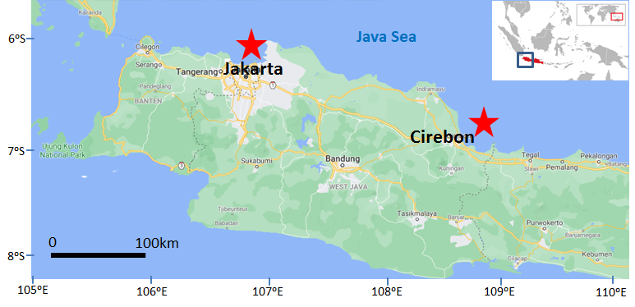
Figure 1. Location of the sample collection
In order to evaluate the MP contamination in fish species, at least ten individuals of each fish species were provided directly from fishermen in the study area. Five fish species were collected from Jakarta Bay, i.e. rabbitfish (Siganus javus), croaker (Agyrosomus amoyensis), sea catfish (Netuma thalassina), bigeye (Priacanthus sp), and fringescale sardine (Sardinella fimbriata). Additionally, three fish species were provided from Cirebon Bay, i.e. rabbitfish (Siganus javus), croaker (Agyrosomus amoyensis), and anchovy (Stolephorus comersonii). Most of the fish samples are benthic species, except S. fimbriata and S. comersonii, which are classified as pelagic species. All fish samples were conserved at chilling temperature and transported to the laboratory in Jakarta.

Microplastic analysis
Identification of MP profiles included MP concentration and distribution in gill and digestive/gut organs, type of MP polymer, shape, color, and size. A number of 3 individual fish samples were randomly selected from each fish species, i.e. 5 species from Jakarta Bay and 3 species from Cirebon Bay. Fish samples were dissected and treated in a clean-air room to reduce environmental contamination. All glassware and equipment were pre-cleaned with Milli-Q water, and a blank protocol was performed as a quality control procedure.
Microplastic was isolated and identified following the method of Avio et al. (2015). The fish MP was isolated from oven-dried organs (gastrointestinal tract/gut and gill). Microplastic in each organ was separated from organic materials with 50 ml of concentrated H₂O₂ 30% (Merck) at 60ᵒC for 24 hours. Density separation was performed with 150 ml concentrated NaCl (Merck) and filtered with a glass microfiber filter of 2.7 µm pore size and 4.7 cm diameter (Whatman GF/D) under vacuum conditions.
Density separation and filtration were repeated 2 times to ensure all MP had been extracted. The visualization and quantification of MP objects were observed by a binocular microscope (Olympus BX-53) equipped with a DP21 camera at 40x magnification. The composition of the MP polymer was identified using a universal ATR-FTIR spectrometer (PerkinElmer-Spectrum One) by comparing the spectra to that of commercial standard or reference materials at 400-4000 cm⁻¹ and co-adding of 16 scans at a resolution of 4 cm⁻¹.

Results
Microplastic abundance in fish samples
In the present study, MP was found in all fish species, either from Jakarta Bay or Cirebon Bay. However, minor samples (3/22 or 13.64% of the individual samples) showed no MP contamination, namely in one sample of S. fimbriata, S. javus, and A. amoyensis, respectively. Additionally, some fish samples showed that MP was only identified in the gut or gill organ. In general, MP concentration in fish from Cirebon Bay was slightly higher than that from Jakarta Bay, with S. javus known as the most contaminated species in both locations at an average concentration of 11.33 and 15.00 particles/fish (Figure 2A). Similar to S. javus, Priacanthus sp from Jakarta Bay was also known to be relatively contaminated by MP at an average concentration of 14 particles/fish, whereas this species was not provided from Cirebon Bay. A pelagic species of S. fimbriata collected from Jakarta Bay was known as the least contaminated species by MP, i.e. 2 particles/fish on average. Microplastic contamination was more dominant on the gill organ of fish samples from Jakarta Bay, in contrast with that from Cirebon Bay (Figure 2B). This difference could be associated with the fact that MP profiles (shape, polymer, and size) in both locations are relatively varied.

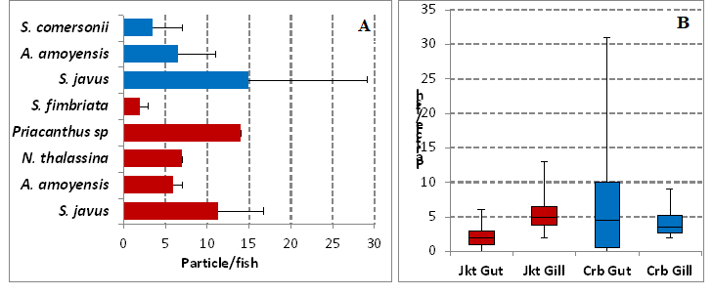
Figure 2. Microplastic concentration in different fish species from Jakarta Bay/Jkt (red bars) and Cirebon Bay/Crb (blue bars) (A: concentration based on species; B: concentration in gut and gill organs)

The gill and gut are common organs to accumulate MP in fish species (Su et al., 2019). In the present study, MP concentration was identified at relatively comparable concentrations in fish guts and gills from both locations. However, a relatively high concentration of MP in fish guts and gills was investigated in Cirebon Bay. This could be related to the different sizes and shapes of fish MP from Jakarta Bay and Cirebon Bay, reflecting the different sources of plastic waste emission in both regions. Since the smaller size of MP (0.1-1.0 mm) was more dominant in fish from Cirebon Bay (Figure 5A), this size is relatively accumulated more in the gill rather than in the gut, as also reported by Su et al. (2019). The most dominant MP in fish gills from Jakarta Bay could be associated with the predominant fiber MP in Jakarta Bay, in contrast to that in Cirebon Bay (Figure 3A). Another reason is that MP accumulation in the gill is a non-selective process as the gill can capture MP passively by filtration. In contrast, MP exposure in the gut could be accidentally ingested from the water column and seabed or from the adhered MP into natural feed (Neves et al., 2015).

Type, size, and color of microplastic
As presented in Figure 3A, the predominantly MP contamination in Jakarta Bay was fiber, while in Cirebon Bay was fragment. Microplastics in the form of granules were identified in the minor fish gut (2% of total samples) in both locations. In contrast, film MP was only detected in 4% of fish samples, especially from Cirebon Bay, both in the gut and gill organs. Identification of the polymer with FTIR showed that polyethylene (PE), polyvinyl chloride (PVC), and polypropylene (PP) were the most dominant MP in the fish samples from Jakarta Bay and Cirebon Bay (Figure 4B). In Cirebon Bay, PE was significantly more dominant than the other polymers, while in Jakarta Bay, PE and PVC presented relatively similarly in fish samples. The examples of identified MP and their FTIR spectra are presented in Figure 4.
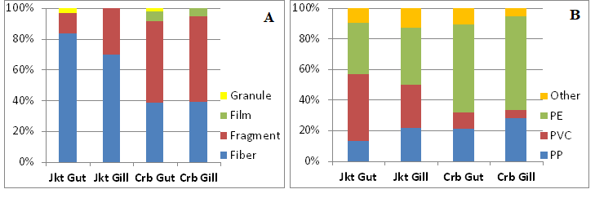
Figure 3. Microplastic profile in the gut and gill organs of fish from Jakarta Bay (Jkt) and Cirebon Bay (Crb) based on microplastic shape (A) and plastic polymer (B)

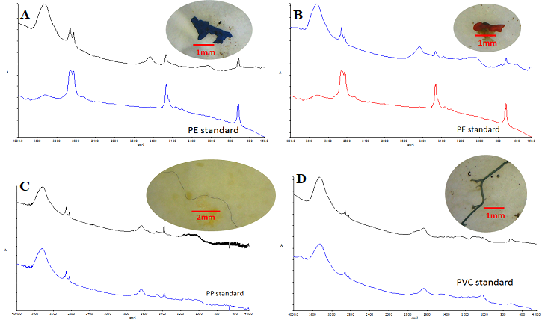
Figure 4. Visualization of microplastic samples and the FT-IR spectra
(A-B: PE fragments; C-D: PP and PVC fibers)

Based on the MP size showed that the majority of the identified plastics (65%) were the small size of less than 1 mm, while the bigger MP (1-5mm) accounted for 31%. Additionally, there were minor MP (4 % of the total samples) with a size of more than 5 mm found in the fish gut from Jakarta Bay (Figure 5A). Due to the instrumentation limit, the MP less than 0.1 mm could not be identified in the present study. Further identification of MP color revealed that the most dominant MP in fish from both locations was blue, black, and red with slightly different compositions between in gut and gill organs (Figure 5B). Other colors that present inconsistently only in the gut organ are green, white, and transparent.
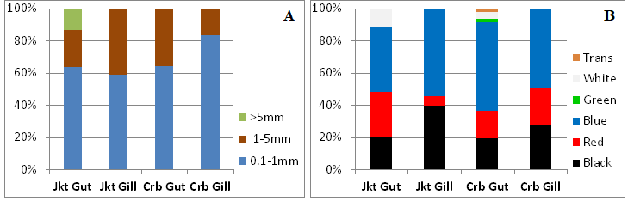
Figure 5. Distribution of microplastic in different organs of fish from Jakarta Bay (Jkt) and
Cirebon Bay (Crb) based on microplastic size (A) and microplastic color (B)

Accumulation of MP in fish gills could be vulnerable due to the possible acute toxicity to fish (Barboza et al., 2018). More attention has been paid to MP due to its invisible size and the potential to endanger human health. Less than 20 µm MP may be transported to the human internal organ, while the smaller one (<10 µm) could penetrate the cell membrane and transport through the vascular system (Bouwmeester et al., 2015; Visali et al., 2021). Studies also reported that exposure to MP might affect the immune system (Lusher et al., 2017) and intestinal disorders ((Visalli et al., 2021).
The different composition of MP shapes in fish from both locations could indicate the different profiles of MP pollution in Jakarta Bay and Cirebon Bay. The result in Jakarta Bay is in line with the earlier study in PIK mangrove, Baron Bay, Bali Strait, and Papua, which showed fiber as the most dominant MP in fish (Hastuti et al., 2019; Sarasita et al., 2020; Suwartiningsih et al., 2020; Yona et al., 2020). In contrast, the fragment was reported as the most dominant MP in fish from Makassar and Pangandaran Bay (Ismail et al., 2019; Rochman et al., 2015). The different shapes of MP could be attributed to the different types of polymers that affect the accumulation pattern in fish as they have different degradation rates, sizes, and densities.
The composition of plastic polymer in fish from Jakarta Bay and Cirebon Bay supported the different profiles of MP pollution in both locations. PE is also known as the most reported MP in fish globally, followed by polystyrene (PS) and PP (de Sá et al., 2018). The result in Jakarta Bay is in line with the investigation that reported PE and PP are the most dominant meso and macroplastic pollution in the surface water of Jakarta Bay (Dwiyitno et al., 2020). A similar result was reported from the study in fish from Bali Strait, which showed PE and PVC is the most dominant MP (Sarasita et al., 2020). Nevertheless, no available study on plastic pollution in Cirebon Bay, either in water or sediment samples.
A relatively similar result was revealed in MP color in fish from Jakarta Bay and Cirebon Bay. Blue, black, and red are the most dominant colors, with minor additional colors of green, white, and transparent in the gut organ. Black MP was also reported as the most dominant in fish from Baron Bay (Suwartiningsih et al., 2020), while white and transparent were reported as the most dominant MP from fish in Bengkalis and PIC mangrove, respectively (Amin et al., 2020; Hastuti et al., 2019). Since the majority of MP is a secondary product from macroplastic, MP color could reflect the origin of macroplastic pollution in the study area. An earlier study on meso and macroplastic in Jakarta Bay revealed that the most dominant plastic litter comes from consumer products, packaging, and fishing gear (Dwiyitno et al., 2020).

Comparison to other studies
Compared to the earlier studies, the concentration of MP in fish samples from Jakarta Bay and Cirebon Bay in the present study is relatively higher than that reported from Bali Strait (Sarasita et al., 2020) but comparable to that reported from Makassar (Rochman et al., 2015), Pangandaran Bay (Ismail et al., 2019), and PIK mangrove (Hastuti et al., 2019). A more concentrated MP was reported from Bengkalis (63 particles/fish) and Baron Bay (46 particles/fish), as reported by Amin et al. (2020) and Suwartiningsih et al. (2020).
Table 1 summarizes the MP contamination in fish samples from different Indonesian and some Asian waters as a comparison. However, the result is difficult to compare due to the different methods, sampling locations, and fish species. Compared to the other Asian waters (Malaysia, China, and Japan), the MP concentration in fish from Jakarta Bay and Cirebon Bay was relatively higher. However, the MP profiles were relatively similar to those from Malaysia and Japan, especially in shape, size, and polymer type.
Table 1. Profile of microplastic in fish from Indonesian coasts and some Asian waters
Location | Target organ | Nr. of species | Microplastic  (particle/fish) | Dominant microplastic |  |  |  | Ref.
 |  |  |  | Shape | Color | Size (mm) | Polymer** | Ref.
Jakarta Bay, INA | Gut, Gill | 5 | 0-19 | Fiber | Blue, Black | 0.1-1.0 | PE, PVC | This study
Cirebon Bay, INA | Gut, Gill | 3 | 0-34 | Fragment | Blue, Black | 0.1-1.0 | PE, PP | This study
Baron Bay, INA | Gut | 4 | 7-97 | Fiber | Black | 0.05-0.1 | PA | [1]
Bengkalis, INA | Gut | 3 | 56-72 | Film | White | 0.1-0.5 | NA | [2]
Makassar, INA | Gut | 10 | 0-21 | Fragment | NA | +3.5 | NA | [3]
Bali Strait, INA | Gut | 4 | 4-7 | Fiber, Film | NA | NA | Varied | [4]
PIK Mangrove, INA | Gut | 9 | 0-52 | Fiber | Transparent | 0.06-0.08 | NA | [5]
Pangandaran, INA | Gut | 2 | 2-28 | Fragment | Varied | Varied | NA | [6]
Papua, INA | Gut, Gill | 8 | 1.6-16.5* | Fiber | NA | >1.0 | NA | [7]
Malaysia | Gut, Gill | 11 | 0-10 | Fragment | NA | 0.1-0.5 | PP | [8]
Yangtze, China | Gut | 13 | 1-7 | Fiber | Transparent | 2.0-5.0 | CE | [9]
Tokyo, Japan | Gut | 1 | 2.3 | Fragment | NA | <1.0 | PE, PP | [10]

INA: Indonesia; NA: not applicable; *: (particle/g);
**PE: Polyethylene, PVC: Polyvinylchloride, PP: Polyprophylene, PA: Polyamide, CA: Celophane
^{[1]} (Suwartiningsih et al., 2020), ^{[2]} (Amin et al., 2020), ^{[3]} (Rochman et al., 2015),
^{[4]} (Sarasita et al., 2020), ^{[5]} (Hastuti et al., 2019), ^{[6]} (Ismail et al., 2019), ^{[7]} (Yona et al., 2020),
^{[8]} (Karbalaei et al., 2019), ^{[9]} (Jabeen et al., 2017), ^{[10]} (Tanaka & Takada, 2016)

With regard to the fish species, we found the MP in benthic species (S. javus and Priancanthus sp) is more concentrated than that in pelagic fish (S. fimbriata and S. comersonii). This result is in accordance with the earlier study conducted in PIK mangrove reported by (Hastuti et al., 2019) that the same genus of Siganus (S. canaliculatus) was the most concentrated species by MP (4-52 particles/fish). The different concentrations of MP between pelagic and benthic species could be associated with feeding and migratory behaviors. Benthic species tend to ingest more MP, as most of them sink to the seabed depending on the density (Bellas et al., 2016). In contrast, pelagic fish accumulate MP in the water column. It is essential to compare MP profiles in fish samples and water or sediment compartments as a suggestion for future study.

Conclusion
Microplastics were found in all fish species, either from Jakarta Bay or Cirebon Bay. In general, MP concentration in fish from Cirebon Bay was slightly higher than that from Jakarta Bay, with S. Javus known as the most contaminated species in both locations. Microplastic contamination was more concentrated on the gill organ of fish samples from Jakarta Bay, in contrast with that from Cirebon Bay. The predominantly MP contamination in Jakarta Bay was fiber, while in Cirebon Bay was fragment with minor granules and film in both locations. PE, PVC, and PP were the most dominant MP in the fish samples from both study areas. Microplastic size showed that the majority (65%) was the small size of less than 1 mm, compared to the bigger one (1-5 mm), while blue, black, and red are the predominantly MP color in both locations.

References
Amin, B., Febriani, I. S., Nurrachmi, I., & Fauzi, M. (2020). Microplastics in Gastrointestinal Track of Some Commercial Fishes from Bengkalis Waters, Riau Province Indonesia. Journal of Physics: Conference Series, 1655(1). https://doi.org/10.1088/1742-6596/1655/1/012122
Avio, C. G., Gorbi, S., & Regoli, F. (2015). Experimental development of a new protocol for extraction and characterization of microplastics in fish tissues: First observations in commercial species from Adriatic Sea. Marine Environmental Research, 111, 18–26. https://doi.org/10.1016/j.marenvres.2015.06.014
Avio, C. G., Gorbi, S., & Regoli, F. (2017). Plastics and microplastics in the oceans: From emerging pollutants to emerged threat. Marine Environmental Research, 128, 2–11. https://doi.org/10.1016/j.marenvres.2016.05.012
Barboza, L. G. A., Dick Vethaak, A., Lavorante, B. R. B. O., Lundebye, A. K., & Guilhermino, L. (2018). Marine microplastic debris: An emerging issue for food security, food safety and human health. Marine Pollution Bulletin, 133(June), 336–348. https://doi.org/10.1016/j.marpolbul.2018.05.047
Bellas, J., Martínez-Armental, J., Martínez-Cámara, A., Besada, V., & Martínez-Gómez, C. (2016). Ingestion of microplastics by demersal fish from the Spanish Atlantic and Mediterranean coasts. Marine Pollution Bulletin, 109(1), 55–60. https://doi.org/10.1016/j.marpolbul.2016.06.026
Cordova, M. R., & Nurhati, I. S. (2019). Major sources and monthly variations in the release of land-derived marine debris from the Greater Jakarta area, Indonesia. Scientific Reports, 9(1), 1–8. https://doi.org/10.1038/s41598-019-55065-2
de Sá, L. C., Oliveira, M., Ribeiro, F., Rocha, T. L., & Futter, M. N. (2018). Studies of the effects of microplastics on aquatic organisms: What do we know and where should we focus our efforts in the future? Science of the Total Environment, 645, 1029–1039. https://doi.org/10.1016/j.scitotenv.2018.07.207
Devriese, L. I., De Witte, B., Vethaak, A. D., Hostens, K., & Leslie, H. A. (2017). Bioaccumulation of PCBs from microplastics in Norway lobster (Nephrops norvegicus): An experimental study. Chemosphere, 186, 10–16. https://doi.org/10.1016/j.chemosphere.2017.07.121
Dwiyitno, D., Andayani, F., Anissah, U., Januar, H. I., & Wibowo, S. (2020). Concentration and characteristic of floating plastic debris in jakarta bay: A preliminary study. Squalen Bulletin of Marine and Fisheries Postharvest and Biotechnology, 15(3), 109–117. https://doi.org/10.15578/squalen.v15i3.462
Dwiyitno, Dsikowitzky, L., Nordhaus, I., Andarwulan, N., Irianto, H. E., Lioe, H. N., Ariyani, F., Kleinertz, S., & Schwarzbauer, J. (2016). Accumulation patterns of lipophilic organic contaminants in surface sediments and in economic important mussel and fish species from Jakarta Bay, Indonesia. Marine Pollution Bulletin, 110(2), 767–777. https://doi.org/10.1016/j.marpolbul.2016.01.034
Fitri, S., & Patria, M. P. (2019). Microplastic contamination on Anadara granosa Linnaeus 1758 in Pangkal Babu mangrove forest area, Tanjung Jabung Barat district, Jambi. Journal of Physics: Conference Series, 1282(1). https://doi.org/10.1088/1742-6596/1282/1/012109
Hastuti, A. R., Lumbanbatu, D. T. F., & Wardiatno, Y. (2019). The presence of microplastics in the digestive tract of commercial fishes off pantai Indah Kapuk coast, Jakarta, Indonesia. Biodiversitas, 20(5), 1233–1242. https://doi.org/10.13057/biodiv/d200513
Ismail, M. R., Lewaru, M. W., & Prihadi, D. J. (2019). Microplastics Ingestion by Fish in The Pangandaran Bay, Indonesia. 23(January), 173–181. http://www.worldnewsnaturalsciences.com/wp-content/uploads/2019/01/WNOFNS-23-2019-173-181-2.pdf
Jabeen, K., Su, L., Li, J., Yang, D., Tong, C., Mu, J., & Shi, H. (2017). Microplastics and mesoplastics in fish from coastal and fresh waters of China. Environmental Pollution, 221, 141–149. https://doi.org/10.1016/j.envpol.2016.11.055
Jambeck, J. R., Geyer, R., Wilcox, C., Siegler, T. R., Perryman, M., Andrady, A., Narayan, R., & Law, K. L. (2015). Plastic Waste Inputs from Land into the Ocean. Science, 347, 768–771. https://doi.org/10.1126/science.1260352
Karbalaei, S., Golieskardi, A., Hamzah, H. B., Abdulwahid, S., Hanachi, P., Walker, T. R., & Karami, A. (2019). Abundance and characteristics of microplastics in commercial marine fish from Malaysia. Marine Pollution Bulletin, 148(May), 5–15. https://doi.org/10.1016/j.marpolbul.2019.07.072
Kim, J. S., Lee, H. J., Kim, S. K., & Kim, H. J. (2018). Global Pattern of Microplastics (MPs) in Commercial Food-Grade Salts: Sea Salt as an Indicator of Seawater MP Pollution. Environmental Science and Technology, 52(21), 12819–12828. https://doi.org/10.1021/acs.est.8b04180
Lusher, A., Hollman, P., & Mendozal, J. (2017). Microplastics in fisheries and aquaculture: status of knowledge on their occurrence and implications for aquatic organisms and food safety. In FAO Fisheries and Aquaculture Technical Paper 615. https://doi.org/978-92-5-109882-0
Neves, D., Sobral, P., Ferreira, J. L., & Pereira, T. (2015). Ingestion of microplastics by commercial fish off the Portuguese coast. Marine Pollution Bulletin, 101(1), 119–126. https://doi.org/10.1016/j.marpolbul.2015.11.008
OECD. (2020). Marine Plastics Pollution in Indonesia. 2019, 1–4. http://dx.doi.org/10.2760/062975.
Ribeiro, F., Garcia, A. R., Pereira, B. P., Fonseca, M., Mestre, N. C., Fonseca, T. G., Ilharco, L. M., & Bebianno, M. J. (2017). Microplastics effects in Scrobicularia plana. Marine Pollution Bulletin, 122(1–2), 379–391. https://doi.org/10.1016/j.marpolbul.2017.06.078
Ribeiro, F., Okoffo, E. D., O’Brien, J. W., O’Brien, S., Harris, J. M., Samanipour, S., Kaserzon, S., Mueller, J. F., Galloway, T., & Thomas, K. V. (2021). Out of sight but not out of mind: Size fractionation of plastics bioaccumulated by field deployed oysters. Journal of Hazardous Materials Letters, 2(February), 100021. https://doi.org/10.1016/j.hazl.2021.100021
Rochman, C. M., Tahir, A., Williams, S. L., Baxa, D. V, Lam, R., Miller, J. T., Teh, F., Werorilangi, S., & Teh, S. J. (2015). Anthropogenic debris in seafood : Plastic debris and fibers from textiles in fish and bivalves sold for human consumption. Nature Publishing Group, August, 1–10. https://doi.org/10.1038/srep14340
Sarasita, D., Yunanto, A., & Yona, D. (2020). Microplastic content in four economically important fishes from Bali Strait. Indonesian Ichtiology Journal, 20(1), 1–12. https://jurnal-iktiologi.org/index.php/jii/article/view/508/pdf
Su, L., Deng, H., Li, B., Chen, Q., Pettigrove, V., Wu, C., & Shi, H. (2019). The occurrence of microplastic in specific organs in commercially caught fishes from coast and estuary area of east China. Journal of Hazardous Materials, 365, 716–724. https://doi.org/10.1016/j.jhazmat.2018.11.024
Suwartiningsih, N., Setyowati, I., & Astuti, R. (2020). Microplastics in Pelagic and Demersal Fishes of Pantai Baron, Yogyakarta, Indonesia. Biodjati Journal, 5(1), 33–49. https://doi.org/10.15575/biodjati.v5i1.7768
Tanaka, K., & Takada, H. (2016). Microplastic fragments and microbeads in digestive tracts of planktivorous fish from urban coastal waters. Scientific Reports, 6(3), 1–8. https://doi.org/10.1038/srep34351
Visalli, G., Facciolà, A., Ciarello, M. P., De Marco, G., Maisano, M., & Di Pietro, A. (2021). Acute and sub‐chronic effects of microplastics (3 and 10 μm) on the human intestinal cells ht‐29. International Journal of Environmental Research and Public Health, 18(11). https://doi.org/10.3390/ijerph18115833
Yeo, B. G., Takada, H., Yamashita, R., Okazaki, Y., Uchida, K., Tokai, T., Tanaka, K., & Trenholm, N. (2020). PCBs and PBDEs in microplastic particles and zooplankton in open water in the Pacific Ocean and around the coast of Japan. Marine Pollution Bulletin, 151, 110806. https://doi.org/10.1016/j.marpolbul.2019.110806
Yona, D., Maharani, M. D., Cordova, M. R., Elvania, Y., & Dharmawan, I. W. E. (2020). Microplastic analysis in gill and gastrointestinal track of reef fish in three small and outer islands of Papua, Indonesia: a preliminary study. Journal of Tropical Marine Science and Technology, 12(2), 497–507. https://doi.org/10.29244/jitkt.v12i2.25971
Yona, D., Sari, S. H. J., Iranawati, F., Bachri, S., & Ayuningtyas, W. C. (2019). Microplastics in the surface sediments from the eastern waters of Java Sea, Indonesia. F1000Research, 8(May), 1–14. https://doi.org/10.12688/f1000research.17103.1

