Characterization of Cellulose Fibers Extracted from Ulva lactuca with Various NaOH Concentrations

Hari Eko Irianto^{1,3}, Alfitra Raya Rachmana², Dina Fransiska¹, Putri Amanda³, Sakinah Haryati², Rifki Prayoga Aditia², Nurhayati^{1*}

¹National Research and Innovation Agency, Research Center for Marine and Land Bioindustry, Tangerang Selatan, Indonesia 15310
²Sultan Ageng Tirtayasa University, Faculty of Agriculture, Serang, , Indonesia 42111
³National Research and Innovation Agency, Research Center for Biomass and Bioproducts, Cibinong, Indonesia

Abstract
Cellulose fibers are composed of chains that include both amorphous and crystalline phases, contributing to their large surface area and high strength. In this study, Ulva lactuca, a plant rich in cellulose, was used for cellulose fiber extraction through base hydrolysis with NaOH. The primary objective of this research was to determine the optimal NaOH concentration and to characterize the resulting cellulose fibers. To achieve this, various NaOH concentrations (10%, 20%, 30%, and 40%) were employed in the extraction process. The results suggest that a 30% NaOH concentration is optimal for extracting cellulose fibers from U. lactuca. FTIR analysis of the cellulose fibers revealed absorption peaks at O-H (3325 cm⁻¹) and C-H (2912.3 cm⁻¹). XRD analysis showed a diffraction peak at a 2θ angle of 21.48°. The cellulose yield was 4.38%, and the cellulose type was confirmed as α-cellulose, with a crystallinity index of 84.093%.

Keywords: Green seaweed, cellulose fiber, SDGs

Introduction
Cellulose is a polysaccharide composed of glucose units linked by β-1,4-glycosidic bonds, with the chemical formula (C₆H₁₀O₅)n, where n denotes the degree of polymerization (Wang et al., 2020). Cellulose is predominantly derived from plants, which are the primary contributors to its production. It is a key component of plant cell walls, where it exists as a mixture of homologous polymers, often found in combination with other polysaccharides and lignin in varying proportions. Due to its renewability and biodegradability, cellulose has a wide range of industrial applications, including use as a raw material in the production of paper, textiles, and bioplastics.
Ulva lactuca, a green macroalga classified within the Chlorophyceae group, is a significant source of cellulose (Tirpan et al., 2020). U. lactuca contains 30.89 ± 1.87% ash content, 2.24 ± 0.37% fat content, 2.85 ± 0.79% protein content, 7.54 ± 0.19% crude fiber, and 20.86 ± 2.29% carbohydrates (by difference) (Santi et al., 2012). This seaweed is widely distributed along coastlines, making it an abundant and cost-effective biomass resource. Despite its relatively low cellulose content of 2.2%, attributed to the use of very young raw material (Wahlström et al., 2020), U. lactuca offers potential as a renewable source of cellulose. In contrast, Siddhanta et al. (2013) reported a higher cellulose content in green seaweed, ranging from 3.7% to 20%, highlighting variations depending on factors such as the calcareous nature of the seaweed.
The success of cellulose extraction depends heavily on the method used, such as alkaline hydrolysis. NaOH is effective in this process for removing lignin and increasing cellulose content (Tirpan et al., 2020). Similarly, Gomaa et al. (2021) extracted cellulose from U. lactuca and achieved an optimum cellulose yield of 4.82%, with a crystallinity of 72.58%, using a 5% NaOH concentration at 100°C for a 2-hour extraction time. However, further research is still needed to investigate the effects of varying NaOH concentrations during the delignification process of U. lactuca to reveal the most effective NaOH concentration for optimal cellulose extraction.
Given the growing demand for sustainable materials, the utilization of renewable resources such as cellulose from algae, including U. lactuca, aligns with the objectives of SDG (Sustainable Development Goals) 12 (Responsible Consumption and Production) by promoting the use of biodegradable, renewable materials. Furthermore, the development of efficient cellulose extraction methods contributes to SDG 9 (Industry, Innovation, and Infrastructure) by fostering innovation in the production of bioplastics and other eco-friendly materials. By optimizing the use of U. lactuca for cellulose extraction, we also contribute to SDG 14 (Life Below Water), ensuring that seaweed-based biomass is sustainably sourced without harming marine ecosystems (Mogany et al., 2024).

Material and Method
Material
U. lactuca was obtained from Lombok, West Nusa Tenggara, Indonesia. Hydrogen peroxide (H₂O₂) and sodium hydroxide (NaOH) were purchased from CV Anugrah Chemical, Jakarta, Indonesia, while acetic acid (CH₃COOH) was supplied by Glatt Chemical, Bandung, Indonesia.
Preparation of U. lactuca powder
U. lactuca was washed with running water until clean. The preparation of U. lactuca powder began with soaking the seaweed in freshwater for 24 hours to remove dirt and mineral salts. The soaked seaweed was then washed under running water, followed by size reduction of the seaweed. Subsequently, it was dried using an oven at 60–80°C. The dried seaweed was ground into powder using a porcelain mortar and pestle set. The ground seaweed was sieved using a 400-mesh flour sieve and then stored in a plastic container.
Extraction of cellulose fibers
The cellulose extraction from U. lactuca was based on the method by (Nurhayati & Kusumawati, 2014). For the extraction process, 20 grams of U. lactuca powder were placed into a 500 mL beaker. The first step involved the removal of hemicellulose using a 0.5 M CH₃COOH solvent with heating at 80°C for 2 hours and followed by delignification using NaOH solvents (10%, 20%, 30%, 40%) with heating at 80°C for 2 hours. Next, the bleaching process was carried out using a 2% H₂O₂ solution and heated at 80°C for 2 hours. The solution obtained from the extraction process was allowed to stand at ambient temperature. Subsequently, the seaweed residue was filtered using a 400-mesh sieve and washed with distilled water until a neutral pH was achieved. The resulting pulp product was stored at room temperature and dried to obtain cellulose fibers in dry form.
The obtained cellulose fibers were characterized based on yield, functional groups using Attenuated Total Reflectance Infrared (ATR-IR) equipment (Bruker Optics, Germany), thermal stability using Simultaneous Thermal Analysis (PerkinElmer STA 6000, USA), crystallinity index (CrI) using X-ray diffraction (Shimadzu XRD-7000 MaximaX, Japan), and morphology of cellulose using a Thermo Scientific (Italy) field emission scanning electron microscope (FE-SEM).

Results and Discussion
Yield of cellulose
To evaluate the effectiveness of the cellulose extraction process from U. lactuca, this study involved varying the concentration of NaOH for delignification, ranging from 10% to 40%. The cellulose yield from this process ranged from 4.38 ± 0.77% to 5.44 ± 0.27% (Figure 1). Statistical analysis indicated no significant effect of NaOH concentration on cellulose yield (p > 0.05), (1.766>0.292). The properties and yield of extracted cellulose depend on factors such as NaOH concentration and the raw material (Bouredja et al., 2015). For example, concentrations exceeding 17% have been shown to reduce cellulose yield, likely due to overextraction or degradation of the cellulose fibers.
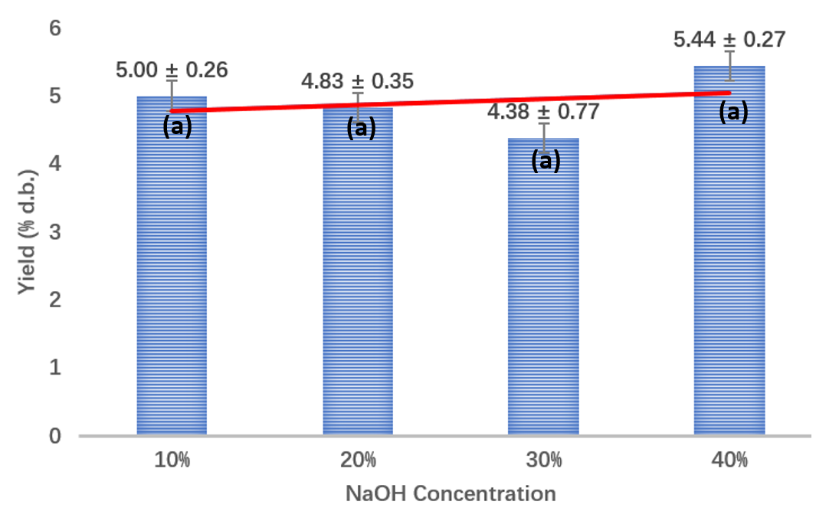
Figure 1. Yield of cellulose fibers extracted from U. lactuca using different NaOH concentrations (The mean values with the same lowercase letter are insignificantly different (p<0.05).

The decrease in yield with increasing NaOH concentration may result from incomplete delignification at low concentrations and excessive dissolution of non-cellulosic components at high concentrations. While higher NaOH levels enhance lignin removal and break bonds between with hemicellulose, overly strong may reduce overall efficiency by dissolving useful biomass. However, increased Na⁺ ions penetration at higher concentrations can also improve cellulose release, potentially increasing yield under optimal conditions (Prasetia et al., 2018).
The highest cellulose yield observed in this study was lower than that reported in studies using lower concentrations of NaOH or alternative pretreatment methods. For instance, (Patrichi et al., 2023) achieved a 20.944% yield of U. lactuca cellulose using a substrate-to-liquor ratio of 1/20, a 90% ethanol concentration, and a 4 g/L salt concentration. Differences in yield between studies can be attributed to the pretreatment methods, extraction conditions, and particularly the source material. Plants with higher fiber content generally yield more cellulose (Nurnasari & Nurindah, 2018). For example, the cellulose content in banana pseudostems varies across studies, with reported values ranging from approximately 45% to 56.4%. For instance, one study indicates that banana pseudostems contain about 49–45% cellulose (Li et al., 2015), while other reports a cellulose content of 56.4% (Diarsa & Gupte, 2021).
Furthermore, the chemical properties of the raw material, such as lignin and hemicellulose content, also significantly influence the yield. In alkaline treatments, Na⁺ ions can penetrate the porous structure of cellulose, altering its crystallinity and facilitating delignification. Strong bases like NaOH can also convert monosaccharides and terminal groups in polysaccharides into carboxylic acids, potentially affecting the chemical structure of the cellulose and reducing its yield (Kim et al., 2016; Knill & Kennedy, 2003).
Visual Description of Cellulose Fiber
Figure 2 illustrates the progressive morphological changes in cellulose fibers after delignification with varying NaOH concentrations. At the initial observation, cellulose fibers appear in their natural state, both in wet and dry conditions. The wet cellulose fibers appear clumped together, indicating that the bonds between the fibers are still strong. After drying, the fibers are more separated but remain relatively coarse in form. A more significant change is observed when the cellulose fibers are extracted with NaOH solution. The higher the NaOH concentration used, the finer and more uniform the resulting cellulose powder becomes. This suggests that NaOH plays a crucial role in breaking the bonds that hold the cellulose fibers together, resulting in smaller particles (Cai et al., 2015; Deivy Andhika Permata et al., 2021).
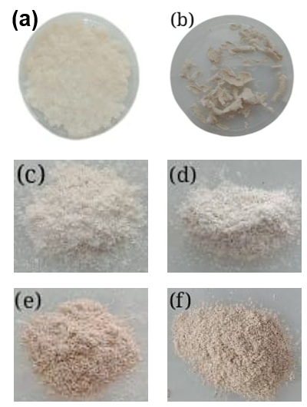
Figure 2: Cellulose fiber in wet state (a), Cellulose fiber in dry state (b), Cellulose fibers extracted from U. lactuca using 10% NaOH (c), Cellulose fibers extracted from U. lactuca using 20% NaOH (d), Cellulose fibers extracted from U. lactuca using 30% NaOH (e), Cellulose fibers extracted from U. lactuca using 40% NaOH (f).

At a 10% NaOH concentration, the cellulose fibers begin to show signs of degradation, though the changes are still relatively minor. As the concentration increases to 20% and 30%, the breakdown of fibers becomes more effective, yielding progressively finer cellulose powder. This is consistent with previous findings that NaOH concentration is directly correlated with the degree of fiber breakdown (Sayakulu & Soloi, 2022). The most significant results are observed in the sample treated with 40% NaOH solution. At this concentration, the cellulose fibers have been maximally degraded, producing a very fine and uniform powder. This indicates that at this concentration, NaOH has successfully separated the cellulose fibers into individual, very small particles, likely due to the complete breakdown of inter-fiber bonds (Budtova & Navard, 2016; Martin-Bertelsen et al., 2020).
These results support the notion that higher NaOH concentrations improve the delignification process and enhance the physical properties of cellulose fibers by breaking down their structural components more efficiently (Bouredja et al., 2015; Utoro et al., 2023).
Fourier Transform Infra-Red (FTIR)
In the FTIR spectrum of U. lactuca cellulose fibers, measured across the wavenumber range of 4000–500 cm⁻¹ (Figure 3), the presence of several distinct peaks confirms the structural integrity of cellulose and the presence of its characteristic functional groups. The O-H stretching vibration peak observed at 3335 cm⁻¹ is particularly important because it signals the hydroxyl (–OH) group, which is essential for the cellulose structure and its ability to form hydrogen bonds. Meenakshi et al. (2002) and Zhao et al. (2019) point out that sharp peaks in the 3700–3000 cm⁻¹ range are indicative of the intra-molecular hydrogen bonding that stabilizes the cellulose polymer. This region reflects the distinctive hydrogen-bonding pattern found in cellulose, which contributes to its crystalline nature and its high degree of hydrophilicity, both important properties in cellulose-based materials.
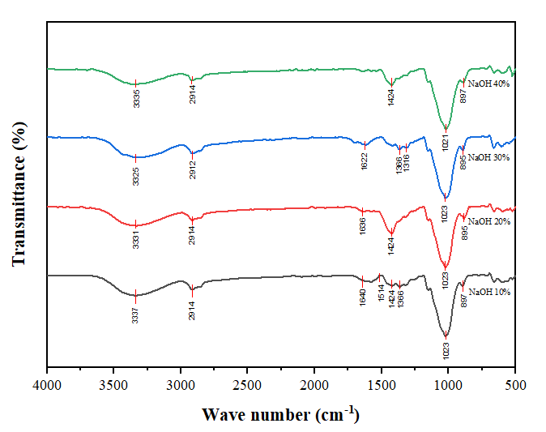
Figure 3: FTIR Spektrum of cellulose fiber extracted from Uva lactuca

Additionally, the peak at 2914 cm⁻¹ corresponds to the C-H stretching vibration, further affirming the presence of cellulose. This absorption is often observed in cellulose structures due to the aliphatic nature of the cellulose backbone (Chen et al., 2018). The presence of such a peak is critical for confirming the carbohydrate-based nature of the material and distinguishing cellulose from other potential contaminants or fibers, such as hemicellulose or lignin.
A significant feature in FTIR analysis is the absence of a peak at around 1730 cm⁻¹, a characteristic absorption for acetyl and uronate ester groups that are commonly found in hemicellulose. This absence is a positive indicator of cellulose purity, suggesting that the treatment process, likely involving alkali or other treatments, successfully removed the hemicellulose content. The absence of this peak aligns with findings by Leite et al. (2017), who note that the absence or reduction of peaks typically linked to hemicellulose and lignin signals a more refined cellulose structure. This purification is critical for various cellulose applications, as the removal of non-cellulosic components enhances the material's mechanical and chemical properties.

Tabel 1 FTIR spectrum and functional group content of cellulose fiber extracted from Uva lactuca
Wavenumber (cm⁻¹⁾ | Functional Groups | Interpretation | Reference
3400 - 3300 | O-H | Cellulose | Cai et al. (2015).
1514 | C-H | Hemicellulose and pectin | Cai et al. (2015).
1640 | OH-Bond | Water molecules adsorbed onto cellulose | Karimi et al. (2014).
2921 - 2923 | C-H | Cellulose | Salem et al. (2022).
669-900 | -(CH₂)_{n} | Cellulose | Karimi et al. (2014).
897 | C-H | Cellulose | Johar et al. (2012).

Furthermore, the minor peak observed at 1640 cm⁻¹ (Table 1), attributed to water adsorption, indicates that despite the cellulose being dried prior to FTIR analysis, residual moisture remains within the fiber matrix. This is consistent with the characteristic bending vibration of the O-H group of water molecules adsorbed onto the cellulose surface. Abidi et al. (2014) explain that water-induced peaks typically appear around 1640 cm⁻¹, as well as in the 3100–3600 cm⁻¹ region, reflecting the moisture content within the material. Water plays a crucial role in cellulose properties, influencing its interaction with other materials and its behavior in various environmental conditions.
Additionally, the absorption band at 897 cm⁻¹, linked to the C-H vibrations of the β-glycosidic linkage, is another hallmark feature of cellulose. This peak confirms the β-D-glucopyranose units that form the primary structure of cellulose (Ding et al., 2020). The β-glycosidic bond is responsible for the rigidity and structural integrity of cellulose, which is crucial for its role as a strong, stable polymer (Etale et al., 2023). This characteristic peak serves as a clear indication of the cellulose’s molecular structure and its ability to form crystalline structures, which directly impacts its mechanical properties and its suitability for various applications in materials science and engineering (Rongpipi et al., 2019).
Treatment with NaOH has been shown to significantly alter the FTIR spectrum, reflecting the dissolution of non-cellulosic components such as lignin and hemicellulose. Alkali treatments are effective at breaking down the ester bonds between cellulose, hemicellulose, and lignin, leading to a more purified cellulose structure. This change in the FTIR spectrum post-treatment signifies the successful removal of these components, further enhancing the quality and utility of the cellulose for various applications (Rongpipi et al., 2019).
X-ray diffraction (XRD)
The XRD spectrum of U. lactuca cellulose fibers, as shown in Figure 4, reveals a prominent peak at 2θ = 21.48°, which is indicative of the α-cellulose crystalline structure. Doh (Doh et al., 2020) points out that a peak in the range of 2θ = 20° to 24° is a characteristic feature of cellulose derived from marine organisms, including seaweed. The XRD spectrum of cellulose typically shows two distinct peaks: one corresponding to the crystalline portion of the cellulose (I002), and another representing the amorphous region (Iam). The crystalline peak (I002) appears at around 21°, while the amorphous peak (Iam) is usually observed at approximately 12°. In this study, the presence of the 21° peak with high intensity suggests that the sample primarily consists of α-cellulose, with a crystallinity index of 84.09%.
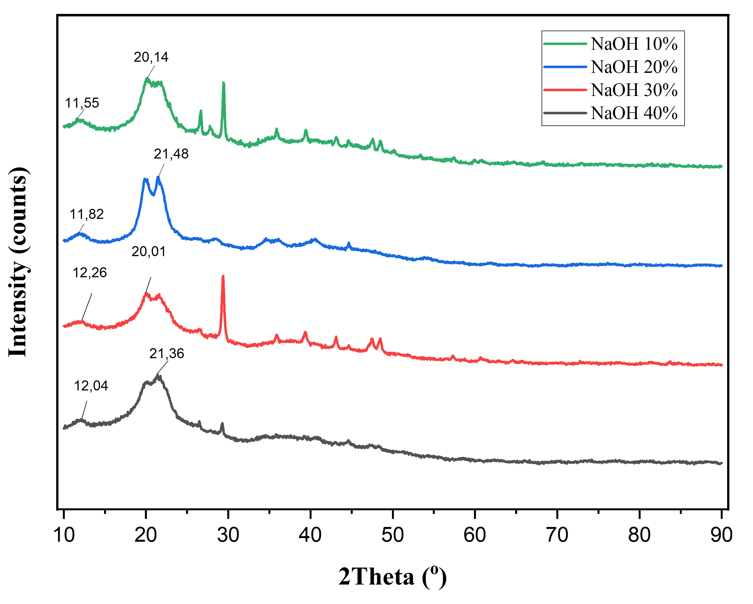
Figure 4: XRD diffractogram of cellulose fibers extracted from Ulva lactuca

Crystallinity of cellulose fibers were affected by the concentration of NaOH used in the extraction process as shown in this study. Cellulose fibers treated with 10% NaOH exhibited the lowest crystallinity (75.34%), whereas fibers treated with 30% NaOH showed the highest crystallinity (84.09%). This result indicates that the alkaline treatment helps to increase the crystalline portion of the cellulose fibers by removing or disrupting the amorphous regions, such as hemicellulose and lignin (Machmudah et al., 2025). A 30% NaOH solution effectively reduces the lignin content, leading to a more ordered cellulose structure. This increase in crystallinity was corroborated by infrared spectroscopy data, which also showed the highest cellulose content in the 30% NaOH-treated fibers.
However, a higher concentration of NaOH (40%) resulted in a noticeable decrease in crystallinity (74.29%), as observed in the XRD analysis. This decrease is likely due to changes in the crystalline structure of the cellulose, which could be attributed to several factors, including the breakdown of crystalline domains by excessive chemical treatments (Ji et al., 2018). Chemical treatments with alkaline can break down the molecular bonds in the crystalline areas, disrupting the structural integrity and leading to reduced crystallinity (Machmudah et al., 2025; Mittal et al., 2011; Sandy et al., 2010).
Simultaneous Thermal Analysis (STA)
Four cellulose fiber samples were tested, each exhibiting distinct thermal behavior. As shown in Figure 5, the cellulose fibers begin to decompose at around 120°C, with two distinct peaks observed in the thermogravimetric curve. The first peak, between 120-150°C, represents the evaporation of water from the fibers, while the second peak, between 250-300°C, is linked to the thermal degradation of the cellulose itself. Johar et al. (2012) explain that this early-stage weight loss is due to the high moisture content in the cellulose fibers. As the temperature increases, the water evaporates completely, causing a sharp decrease in the curve, which indicates the high moisture content of the fibers. This moisture loss absorbs heat, which is reflected as fluctuations in the DSC curve within the temperature range of evaporation, visible across all cellulose samples.

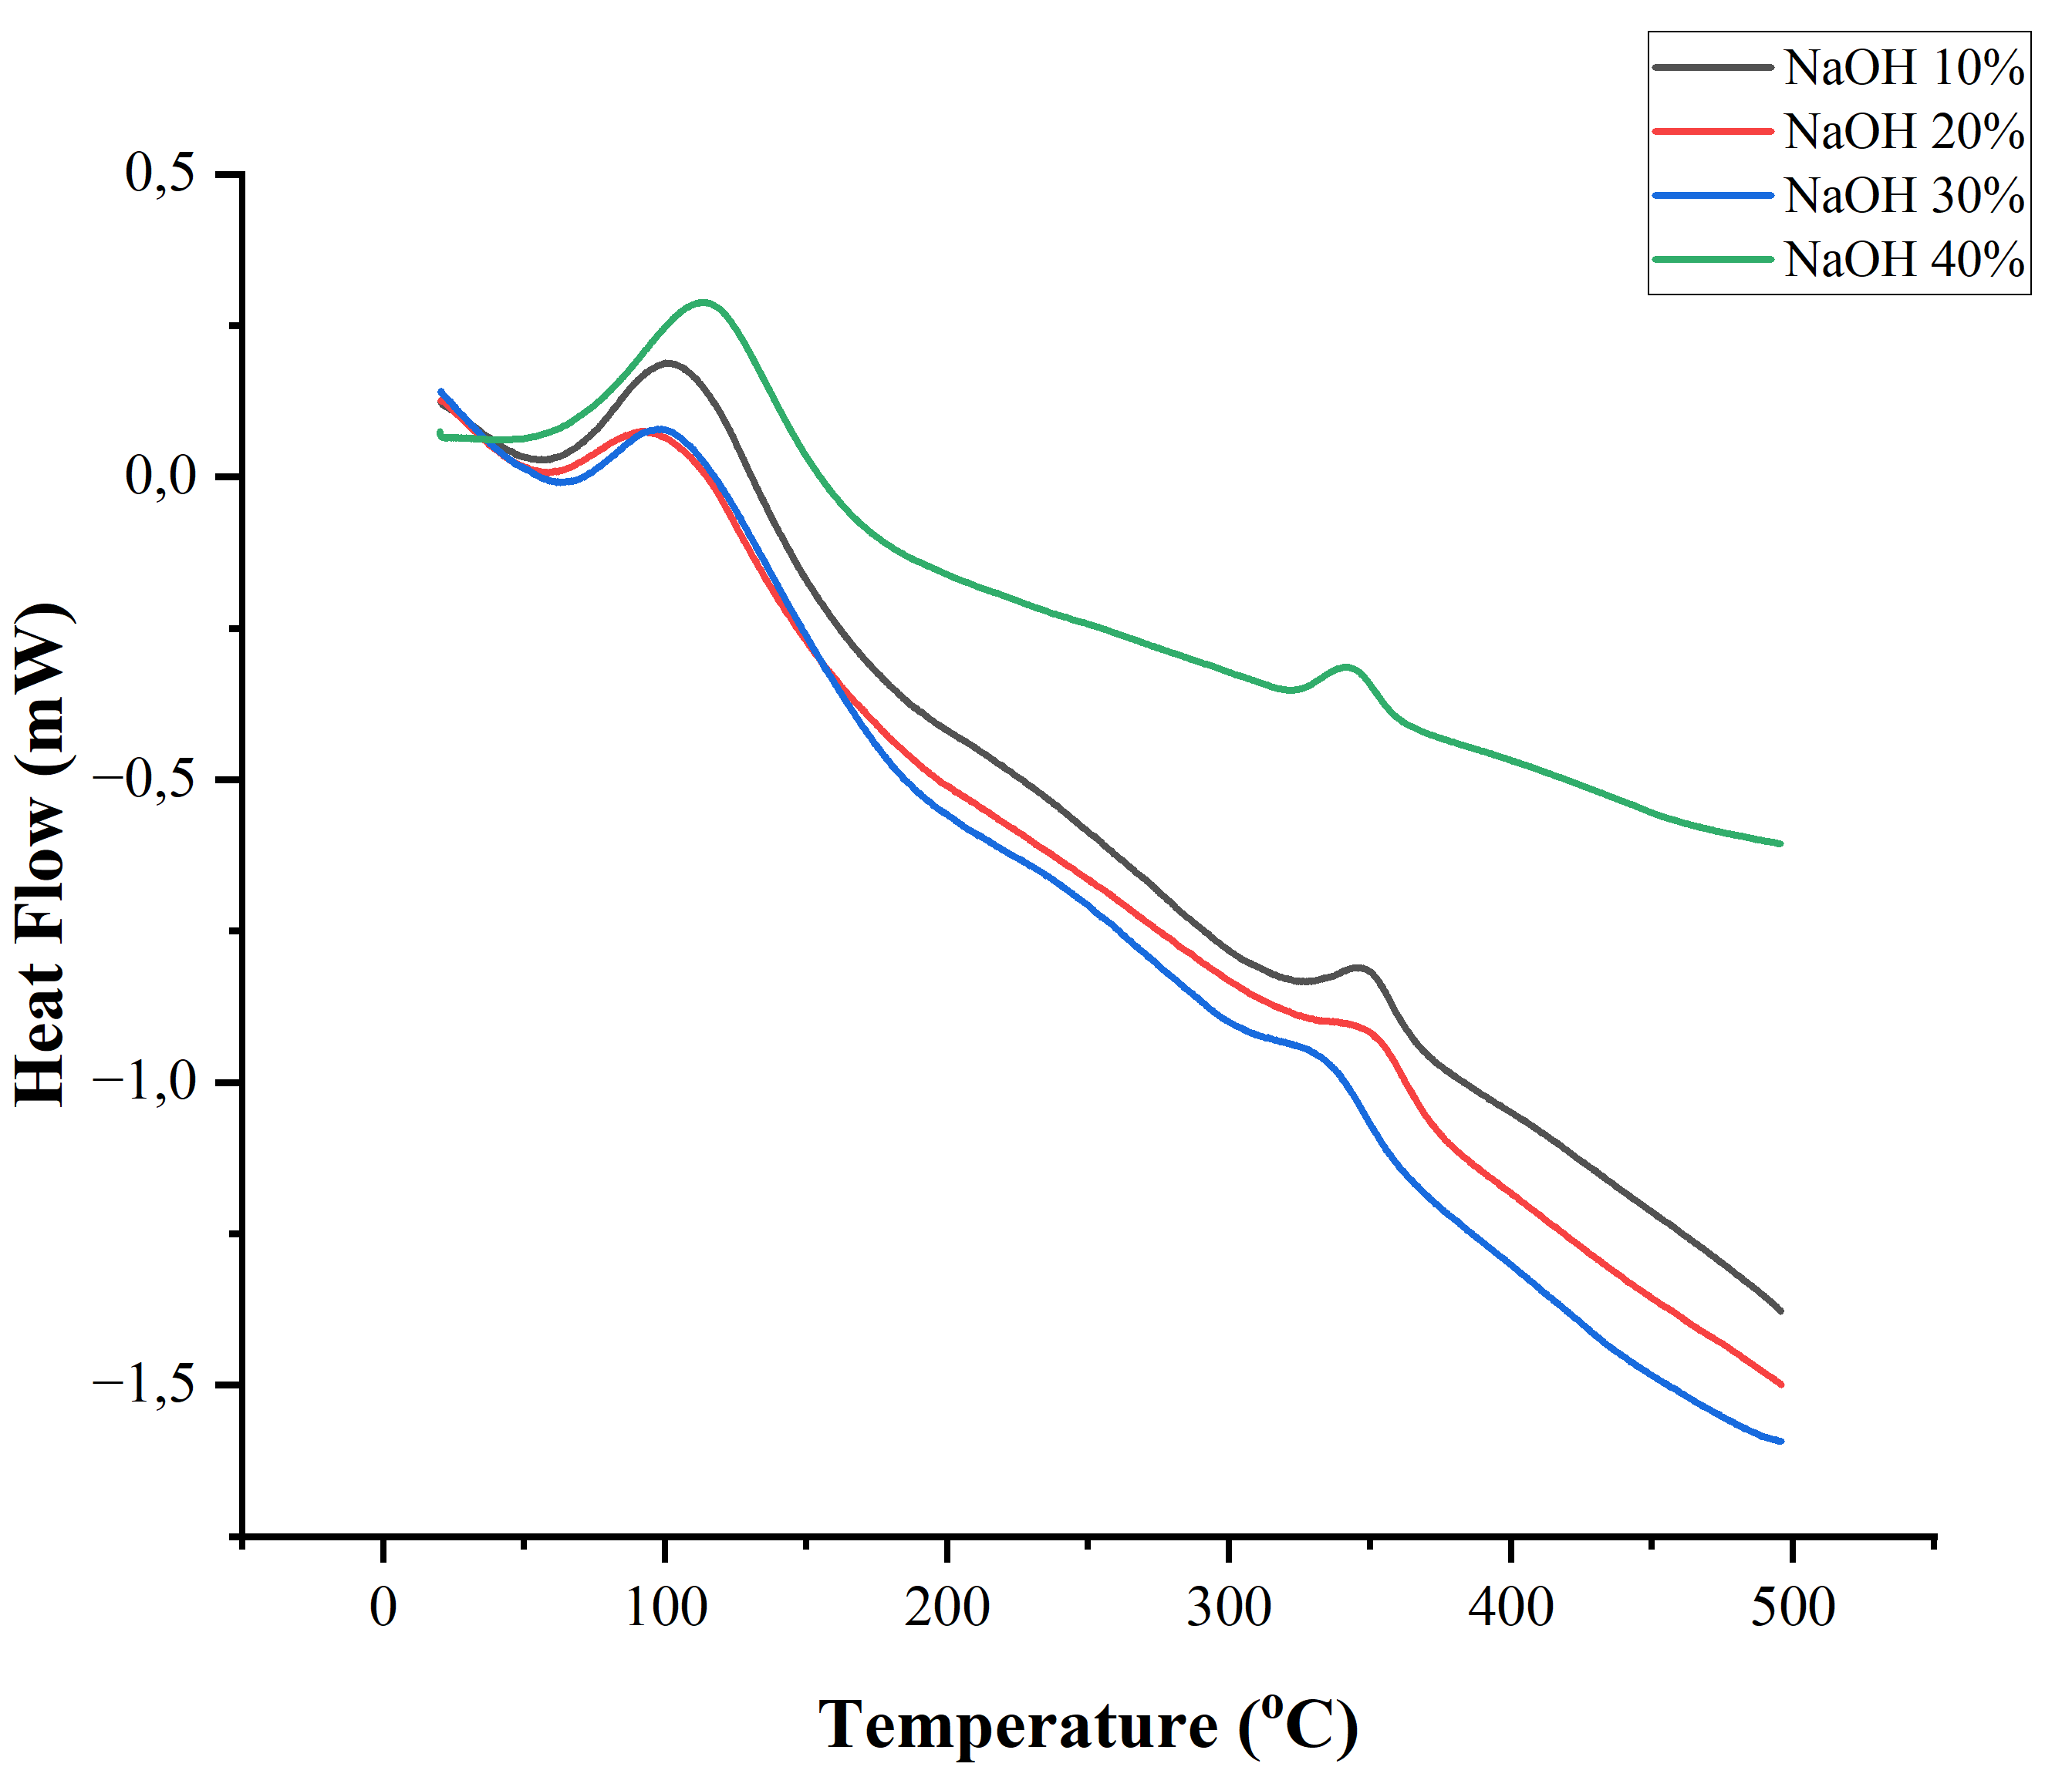  (a) | 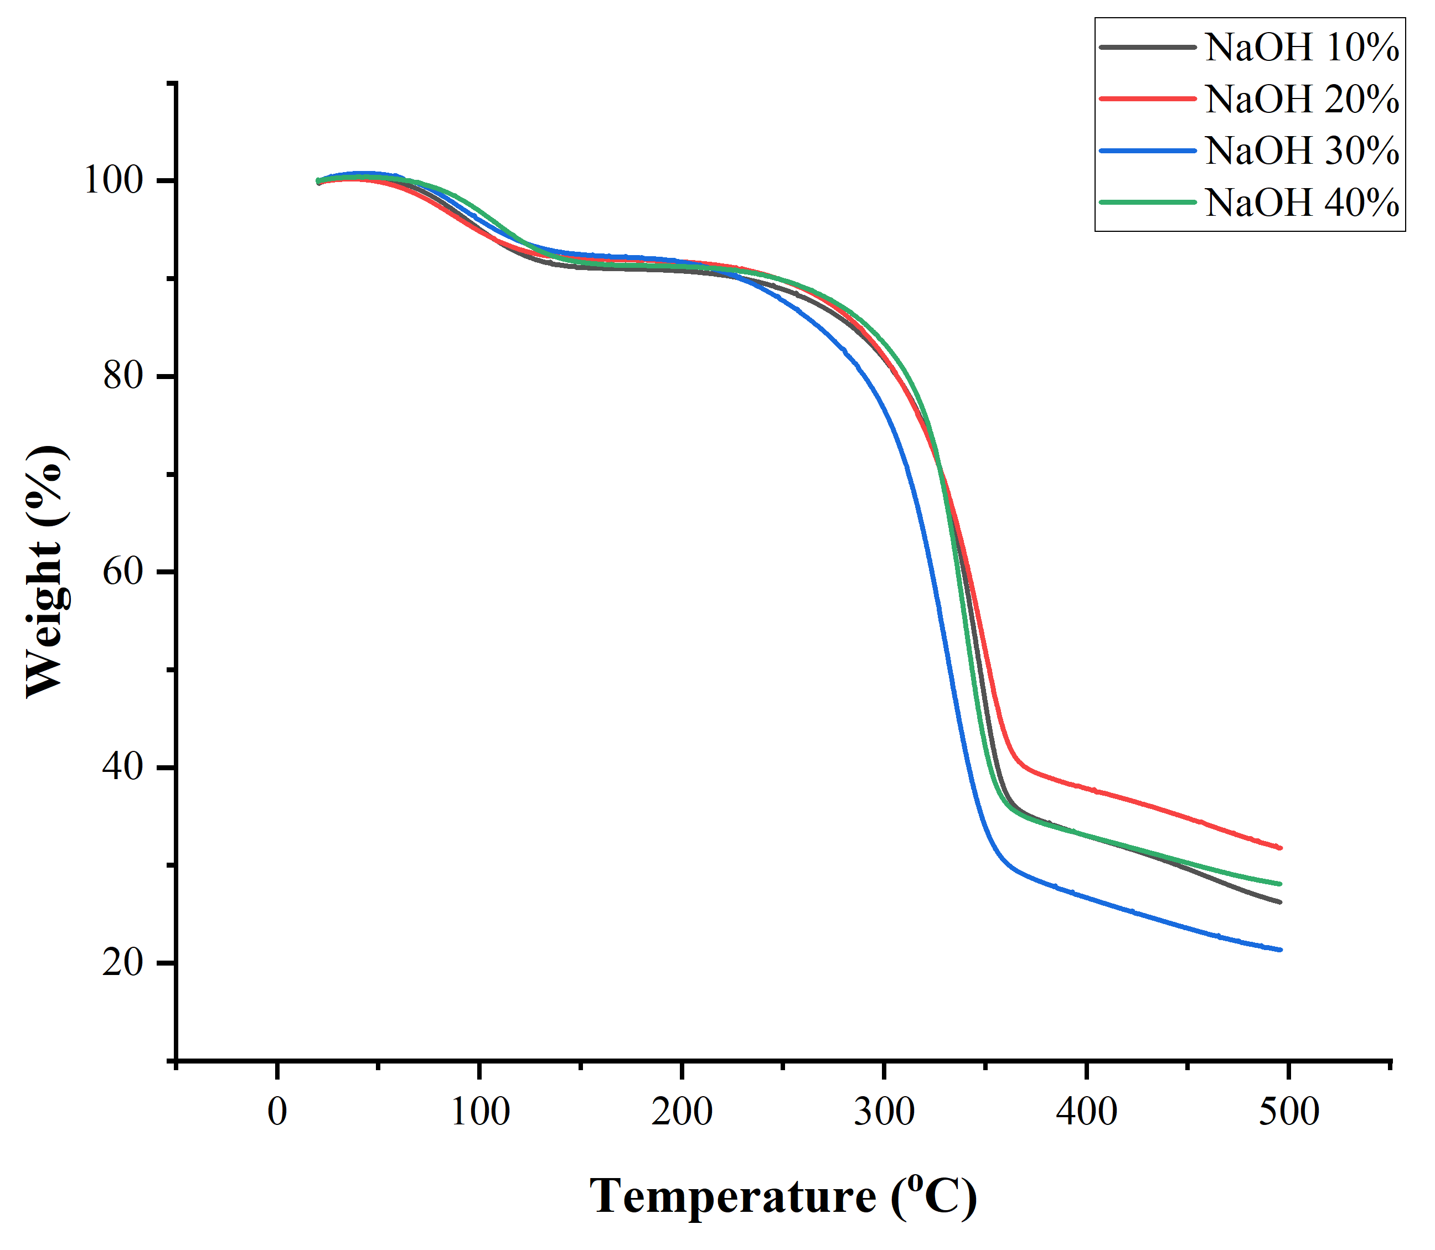  (b)
Figure 5: DSC (a) and TGA (b) curves of cellulose fiber extracted from Ulva lactuca

These findings align with Aulia et al. (2013), who studied cellulose derived from Empty Fruit Bunches (EFB) of oil palm. In their research, they observed a similar weight loss pattern, with cellulose nanocrystals beginning to decompose at around 160°C. The temperature-dependent weight loss in both studies underscore the importance of temperature in cellulose degradation.
The TGA analysis of the cellulose fibers aims to establish a relationship between the loss of mass and temperature. In this study, the cellulose fibers were heated from room temperature up to 500°C. The resulting TGA curve, shown in Figure 5, reveals that from 100°C to 250°C, the cellulose fibers experience significant weight loss, indicating the evaporation of water. After surpassing 350°C, the mass continues to decrease gradually, leaving only a small residue at 500°C. This final mass is notably smaller than the initial sample, highlighting the extent of thermal decomposition (Hideno, 2016).
Morphology of cellulose
The morphological analysis of the cellulose fibers was conducted using FE-SEM magnifications ranging from 5000x to 100,000x. Figure 6 illustrates the differences in the morphology of the four samples. The use of a 40% NaOH solution (Figure 6d) shows cellulose fibers with a denser and smoother sheet-like morphology compared to the 10%, 20%, and 30% NaOH treatments; the surface morphology of the other three samples appears fibrous, indicating the presence of cellulose (Uranchimeg et al., 2022). NaOH can degrade the lignin structure that surrounds cellulose and hemicellulose in lignocellulosic materials (Ciftci et al., 2018).
At the lowest concentration of NaOH (10%), the cellulose fibers appear less organized. Many of the fibers are still grouped together in aggregates, and they have not been fully separated into individual fibers. Additionally, the surface of the fibers looks less clean, which suggests the presence of residual non-cellulosic materials that were not completely dissolved during the extraction process. When the NaOH concentration is increased to 20%, there is a marked improvement in the organization of the fibers. Individual fibers become more distinct and separate from one another, and the overall cleanliness of the fiber surface improves compared to the 10% NaOH treatment. However, the fibers are still somewhat agglomerated, and the surface, though cleaner, is not as polished as it could be.
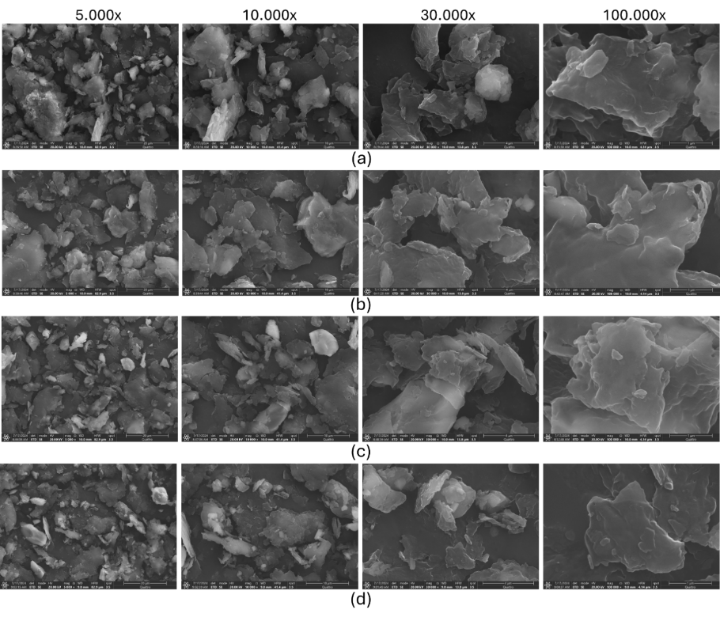
Figure 6: Cellulose fibers extracted from U. lactuca using NaOH solutions: 10% (a), 20% (b), 30% (c), and 40% (d).

At a concentration of 30% NaOH, the cellulose fibers appear to be well-organized and separated. The individual fibers are clearly distinguishable, with their surfaces looking much cleaner. The pores on the fiber surface are more noticeable, which suggests that this concentration has effectively removed a significant amount of the non-cellulosic components, resulting in a purer form of cellulose. Finally, at the highest NaOH concentration of 40%, the cellulose fibers are the most organized and separated. The surface is the cleanest, with the pores of the fibers clearly visible. This suggests that a higher concentration of NaOH is highly effective in removing impurities such as lignin, hemicellulose, and other non-cellulosic components from the cell walls of U. lactuca. As a result, the fibers are purer and their structure is more defined.
These differences in the morphology of the cellulose fibers are likely the result of the varying abilities of NaOH to dissolve components that make up the cell wall of U. lactuca, including lignin, hemicellulose, and pectin. Higher NaOH concentrations (30-40%) enhance the removal of these materials, yielding purer, more porous, and better-stuctured fibers. These improvements are important for enhancing the quality of cellulose extracted from seaweed, making it more suitable for a wide range of applications, such as biocomposites, biofuels, and other industrial uses.
Conclusions
The use of 30% NaOH results in cellulose fibers with high crystallinity. Consequently, these cellulose fibers are ideal for use as reinforcing agents in composites or other structural materials. The high crystallinity of the cellulose also reduces the intermolecular spacing, thereby decreasing the material's ability to absorb water. The best cellulose fibers extracted from Ulva lactuca exhibit distinct FTIR characteristics, with functional group analysis revealing absorption peaks at O-H (3325 cm⁻¹) and C-H (2912 cm⁻¹). XRD analysis shows a diffraction peak at a 2θ angle of 21.48°. The yield obtained was 4.38%, and the cellulose was confirmed to be of the α-cellulose type, with a crystallinity degree of 84.093%. The successful extraction of cellulose from Ulva lactuca in this study highlight the potential of this biomass to contribute to environmentally sustainable growth.
Acknowledgement
This research was supported by the RIIM LPDP Grant with grant number B-842/II.7.5/FR.06/5/2023 and B-2458/III.4/HK/5/2023. The authors express gratitude to the Research Organization for Earth Sciences and Maritime/Research Center for Marine and Land Bioindustry.
References
Abidi, N., Cabrales, L., & Haigler, C. H. (2014). Changes in the cell wall and cellulose content of developing cotton fibers investigated by FTIR spectroscopy. Carbohydrate Polymers, 100, 9–16. https://doi.org/10.1016/j.carbpol.2013.01.074
Aulia, F., Marpongahtun, & Gea, S. (2013). Study on the Preparation of Cellulose Nanocrystals from Oil Palm Empty Fruit Bunches. Jurnal Saintia Kimia, 1(2).
Bouredja, N., Mehdadi, Z., & Bouredja, M. (2015). Extraction of the cellulose and the biometrics of the fibers of the pods of Retamamonosperma (L.). Boissgrowingin natural conditions in the Algerian Western Coast. International Journal of Biosciences, 6(10), 31–38.
Budtova, T., & Navard, P. (2016). Cellulose in NaOH–water based solvents: a review. Cellulose, 23(1), 5–55. https://doi.org/10.1007/s10570-015-0779-8
Cai, M., Takagi, H., Nakagaito, A. N., Katoh, M., Ueki, T., Waterhouse, G. I. N., & Li, Y. (2015). Influence of alkali treatment on internal microstructure and tensile properties of abaca fibers. Industrial Crops and Products, 65, 27–35. https://doi.org/10.1016/j.indcrop.2014.11.048
Chen, W., He, H., Zhu, H., Cheng, M., Li, Y., & Wang, S. (2018). Thermo-Responsive Cellulose-Based Material with Switchable Wettability for Controllable Oil/Water Separation. Polymers, 10(6), 592. https://doi.org/10.3390/polym10060592
Ciftci, D., Flores, R. A., & Saldaña, M. D. A. (2018). Cellulose Fiber Isolation and Characterization from Sweet Blue Lupin Hull and Canola Straw. Journal of Polymers and the Environment, 26(7), 2773–2781. https://doi.org/10.1007/s10924-017-1164-5
Deivy Andhika Permata, Anwar Kasim, Alfi Asben, & Yusniwati. (2021). Delignification of Lignocellulosic Biomass. World Journal of Advanced Research and Reviews, 12(2), 462–469. https://doi.org/10.30574/wjarr.2021.12.2.0618
Diarsa, M., & Gupte, A. (2021). Preparation, characterization and its potential applications in Isoniazid drug delivery of porous microcrystalline cellulose from banana pseudostem fibers. 3 Biotech, 11(7), 334. https://doi.org/10.1007/s13205-021-02838-0
Ding, Q., Han, W., Li, X., Jiang, Y., & Zhao, C. (2020). New insights into the autofluorescence properties of cellulose/nanocellulose. Scientific Reports, 10(1), 21387. https://doi.org/10.1038/s41598-020-78480-2
Doh, H., Lee, M. H., & Whiteside, W. S. (2020). Physicochemical characteristics of cellulose nanocrystals isolated from seaweed biomass. Food Hydrocolloids, 102. https://doi.org/10.1016/j.foodhyd.2019.105542
Etale, A., Onyianta, A. J., Turner, S. R., & Eichhorn, S. J. (2023). Cellulose: A Review of Water Interactions, Applications in Composites, and Water Treatment. Chemical Reviews, 123(5), 2016–2048. https://doi.org/10.1021/acs.chemrev.2c00477
Gomaa, M., Al-Badaani, A. A., Hifney, A. F., & Adam, M. S. (2021). Industrial optimization of alkaline and bleaching conditions for cellulose extraction from the marine seaweed Ulva lactuca. Journal of Applied Phycology, 33(6), 4093–4103. https://doi.org/10.1007/s10811-021-02581-2
Hideno, A. (2016). Comparison of the Thermal Degradation Properties of Crystalline and Amorphous Cellulose, as well as Treated Lignocellulosic Biomass. BioResources, 11(3). https://doi.org/10.15376/biores.11.3.6309-6319
Ji, Y., Peng, Y., Strand, A., Fu, S., Sundberg, A., & Retulainen, E. A. (2018). Fiber Evolution during Alkaline Treatment and Its Impact on Handsheet Properties. BioResources, 13(4). https://doi.org/10.15376/biores.13.4.7310-7324
Johar, N., Ahmad, I., & Dufresne, A. (2012). Extraction, preparation and characterization of cellulose fibres and nanocrystals from rice husk. Industrial Crops and Products, 37(1), 93–99. https://doi.org/10.1016/j.indcrop.2011.12.016
Kim, J. S., Lee, Y. Y., & Kim, T. H. (2016). A review on alkaline pretreatment technology for bioconversion of lignocellulosic biomass. Bioresource Technology, 199, 42–48. https://doi.org/10.1016/j.biortech.2015.08.085
Knill, C. J., & Kennedy, J. F. (2003). Degradation of cellulose under alkaline conditions. Carbohydrate Polymers, 51(3), 281–300. https://doi.org/10.1016/S0144-8617(02)00183-2
Leite, A. L. M. P., Zanon, C. D., & Menegalli, F. C. (2017). Isolation and characterization of cellulose nanofibers from cassava root bagasse and peelings. Carbohydrate Polymers, 157, 962–970. https://doi.org/10.1016/j.carbpol.2016.10.048
Li, W., Zhang, Y., Li, J., Zhou, Y., Li, R., & Zhou, W. (2015). Characterization of cellulose from banana pseudo-stem by heterogeneous liquefaction. Carbohydrate Polymers, 132, 513–519. https://doi.org/10.1016/j.carbpol.2015.06.066
Machmudah, S., Wahyudiono, Trisanti, P. N., Setyawan, H., Madhania, S., Sambodho, K., Winardi, S., Adschiri, T., & Goto, M. (2025). Hydrothermal alkaline treatment of lignocellulosic biomass for microcrystalline cellulose generation at subcritical water. South African Journal of Chemical Engineering, 51, 45–56. https://doi.org/10.1016/j.sajce.2024.10.008
Martin-Bertelsen, B., Andersson, E., Köhnke, T., Hedlund, A., Stigsson, L., & Olsson, U. (2020). Revisiting the Dissolution of Cellulose in NaOH as “Seen” by X-rays. Polymers, 12(2), 342. https://doi.org/10.3390/polym12020342
Meenakshi, P., Noorjahan, S. E., Rajini, R., Venkateswarlu, U., Rose, C., & Sastry, T. P. (2002). Mechanical and microstructure studies on the modification of CA film by blending with PS. Bulletin of Materials Science, 25(1), 25–29. https://doi.org/10.1007/BF02704590
Mittal, A., Katahira, R., Himmel, M. E., & Johnson, D. K. (2011). Effects of alkaline or liquid-ammonia treatment on crystalline cellulose: changes in crystalline structure and effects on enzymatic digestibility. Biotechnology for Biofuels, 4(1), 41. https://doi.org/10.1186/1754-6834-4-41
Mogany, T., Bhola, V., & Bux, F. (2024). Algal-based bioplastics: global trends in applied research, technologies, and commercialization. Environmental Science and Pollution Research, 31(26), 38022–38044. https://doi.org/10.1007/s11356-024-33644-9
Nurhayati, N., & Kusumawati, R. (2014). Sintesis Selulosa Asetat dari Limbah Pengolahan Agar. Jurnal Pascapanen Dan Bioteknologi Kelautan Dan Perikanan, 9(2), 97. https://doi.org/10.15578/jpbkp.v9i2.103
Nurnasari, E., & Nurindah, N. (2018). Chemical Characteristics of Boll, Bast, and Leaf Fibers. Buletin Tanaman Tembakau, Serat & Minyak Industri, 9(2), 64. https://doi.org/10.21082/btsm.v9n2.2017.64-72
Patrichi, C. A. M., Cioroiu Tirpan, D. R., Aljanabi, A. A. A., Trica, B., Gifu, I. C., & Dobre, T. (2023). Extraction of Cellulose from Ulva lactuca Algae and Its Use for Membrane Synthesis. Polymers, 15(24), 4673. https://doi.org/10.3390/polym15244673
Prasetia, I. G. N. J. A., Deviana, S., Damayanti, T., Cahyadi, A., & Wirasuta, M. A. G. (2018). The Effect of NaOH Concentration in Delignification Process on Microcrystalline Cellulose From Green Algae (Cladophora sp.) as The Renewable Marine Product. Journal of Pharmaceutical Sciences and Community, 15(2), 68–71.
Rongpipi, S., Ye, D., Gomez, E. D., & Gomez, E. W. (2019). Progress and Opportunities in the Characterization of Cellulose – An Important Regulator of Cell Wall Growth and Mechanics. Frontiers in Plant Science, 9. https://doi.org/10.3389/fpls.2018.01894
Sandy, M., Manning, A., & Bollet, F. (2010). Changes in the Crystallinity of Cellulose in Response to Changes in Relative Humidity and Acid Treatment. Restaurator, 31(1), 1–18. https://doi.org/10.1515/rest.2010.001
Santi, R. A., Sunarti, T. C., Santoso, D., & Triwisari, D. A. (2012). **Chemical Composition and Polysaccharide Profile of Green Seaweed**. Jurnal Akuatika, III(2), 105–114.
Sayakulu, N. F., & Soloi, S. (2022). The Effect of Sodium Hydroxide (NaOH) Concentration on Oil Palm Empty Fruit Bunch (OPEFB) Cellulose Yield. Journal of Physics: Conference Series, 2314(1), 012017. https://doi.org/10.1088/1742-6596/2314/1/012017
Siddhanta, A. K., Kumar, S., Mehta, G. K., Chhatbar, M. U., Oza, M. D., Sanandiya, N. D., Chejara, D. R., Godiya, C. B., & Kondaveeti, S. (2013). Cellulose Contents of Some Abundant Indian Seaweed Species. Natural Product Communications, 8(4), 497–500. https://doi.org/10.1177/1934578X1300800423
Tirpan, D.-R. C., Koncsag, C. I., & Dobre, T. (2020). Cellulose fibers extraction from Ulva lactuca from the Black Sea. Ovidius University Annals of Chemistry, 31(2), 158–162. https://doi.org/10.2478/auoc-2020-0025
Uranchimeg, K., Jargalsaikhan, B., Bor, A., Yoon, K., & Choi, H. (2022). Comparative Study of the Morphology of Cellulose Nanofiber Fabricated Using Two Kinds of Grinding Method. Materials, 15(20), 7048. https://doi.org/10.3390/ma15207048
Utoro, P. A. R., Alwi, M., Witoyo, J. E., Argo, B. D., Yulianingsih, R., & Muryanto. (2023). Impact of NaOH Concentration and Pretreatment Time on the Lignocellulose Composition of Sweet Sorghum Bagasse for Second-Generation Bioethanol Production (pp. 198–206). https://doi.org/10.2991/978-94-6463-180-7_22
Wahlström, N., Edlund, U., Pavia, H., Toth, G., Jaworski, A., Pell, A. J., Choong, F. X., Shirani, H., Nilsson, K. P. R., & Richter-Dahlfors, A. (2020). Cellulose from the green macroalgae Ulva lactuca: isolation, characterization, optotracing, and production of cellulose nanofibrils. Cellulose, 27(7), 3707–3725. https://doi.org/10.1007/s10570-020-03029-5
Wang, B.-T., Hu, S., Yu, X.-Y., Jin, L., Zhu, Y.-J., & Jin, F.-J. (2020). Studies of Cellulose and Starch Utilization and the Regulatory Mechanisms of Related Enzymes in Fungi. Polymers, 12(3), 530. https://doi.org/10.3390/polym12030530
Zhao, D., Deng, Y., Han, D., Tan, L., Ding, Y., Zhou, Z., Xu, H., & Guo, Y. (2019). Exploring structural variations of hydrogen-bonding patterns in cellulose during mechanical pulp refining of tobacco stems. Carbohydrate Polymers, 204, 247–254. https://doi.org/10.1016/j.carbpol.2018.10.024

