AUTHORS’ STATEMENT

Manuscript title :
Characterization of Cellulose Fibers Extracted from Ulva lactuca with Various NaOH Concentrations

We hereby declare that we agree to submit this manuscript to the Squalen Bulletin of Marine and Fisheries Postharvest and Biotechnology and, if accepted, to transfer the copyright of this article to this bulletin.
We confirm that this manuscript is original without fabrication and plagiarism. It has not been previously published or is being submitted for publication elsewhere.
We warrant that there is no conflict of interest with other people or organization that might be construed to influence the results or interpretation of this manuscript.
We confirm that each listed authors has made a substantial contribution to the manuscript and ensure nobody who qualifies for authorship has been excluded. Main Contributor(s) is(are) marked by an asterisk (*).
Hari Eko Irianto___________________________ Signature 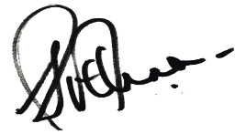
Alfitra Raya Rachmana _____________________ Signature 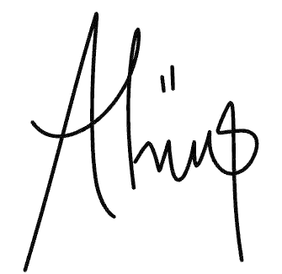
Dina Fransiska____________________________ Signature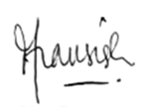
Putri Amanda_____________________________ Signature 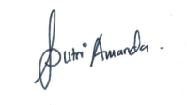
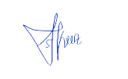
Sakinah Haryati___________________________ Signature
Rifki Prayoga Aditia _______________________ Signature 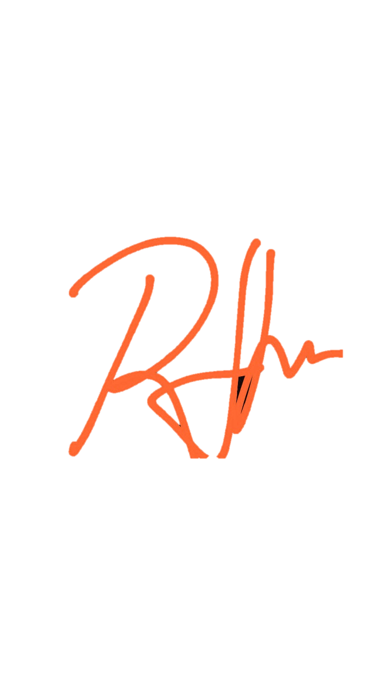
Nurhayati________________________________ Signature 