AUTHORS’ STATEMENT

Manuscript title :
Chemical Composition, In Vitro and In Silico Antioxidant Activity from Microalgae Aurantiochytrium sp. Extract strains Raja Ampat and Kepulauan Seribu

We hereby declare that we agree to submit this manuscript to the Squalen Bulletin of Marine and Fisheries Postharvest and Biotechnology and, if accepted, to transfer the copyright of this article to this bulletin.
We confirm that this manuscript is original without fabrication and plagiarism. It has not been previously published or is being submitted for publication elsewhere.
We warrant that there is no conflict of interest with other people or organization that might be construed to influence the results or interpretation of this manuscript.
We confirm that each listed authors has made a substantial contribution to the manuscript and ensure nobody who qualifies for authorship has been excluded. Main Contributor(s) is(are) marked by an asterisk (*).

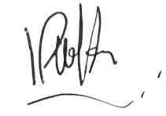


Author : Hardi Astuti Witasari Signature __________________________
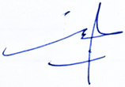
Author : Kintoko Signature __________________________

Author : Nurkhasanah Signature __________________________
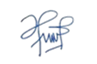
Author : Suhendra Signature __________________________
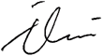
Author : Ahmad Faizal Rangkuti Signature ________________________
Author : Nisrien Ilmia Signature ________________________
Author : Blegoh Iwan Santoso Signature _________________________

Author : Andri Hutari Signature __________________________

