Azila Adnan
Faculty of Science and Marine Environment
Universiti Malaysia Terengganu
21030, Kuala Nerus
Terengganu, Malaysia
azila.adnan@umt.edu.my

Dr. Ariyanti S. Dewi
Editor-in-Chief
Squalen Bulletin of Marine and Fisheries Postharvest and Biotechnology June 16, 2022

Dear Dr. Ariyanti S. Dewi,

I am pleased to submit a mini review article entitled “A Mini Review: Employed Bacterial Species for Bacterial Cellulose Production” by Wan Syahiidah Wan Abd Aziz and Azila Adnan for consideration for publication in Squalen Bulletin of Marine and Fisheries Postharvest and Biotechnology.

In this manuscript, we review the bacterial strains for bacterial cellulose (BC) synthesis. Bacterial cellulose has gained extensive attention in biotechnology research as recognized as versatile microbial products with abundant biotechnology applications. Additionally, BC has also been involved in marine biotechnology research (e.g using marine algae residual sugar for BC synthesis). We believe that this manuscript is ideal for publication by the Squalen Bulletin of Marine and Fisheries Postharvest and Biotechnology because it encompasses the journal themes.

We declare that this manuscript is original, has not been published before and is not currently being considered for publication elsewhere. We know of no conflicts of interest associated with this publication. As Corresponding Author, I confirm that the manuscript has been read and approved for submission by all the named authors. The three suggested reviewers are as followed:

i. Assoc. Prof. Ts. ChM. Dr. Rizafizah Othaman
Universiti Kebangsaan Malaysia
Email: rizafizah@ukm.edu.my

ii. Assoc. Prof. Dr. Anis Shobirin Meor Hashim
Universiti Putra Malaysia
Email: shobirin@upm.edu.my

iii. Assoc Prof. Ts. Dr Mohamad Faizal Ibrahim
Universiti Sains Islam Malaysia
Email: faizal_ibrahim@upm.edu.my

We hope you find our manuscript suitable for publication and look forward to hearing from you in due course. Thank you for your consideration.

Sincerely,


Azila Adnan, PhD
Lecturer, Faculty of Science and Marine Environment
Universiti Malaysia Terengganu
Email: azila.adnan@umt.edu.my

AUTHORS’ STATEMENT

Manuscript title: A Mini Review: Employed Bacterial Species for Bacterial Cellulose (BC) Production
___________________________________________________________________________

We hereby declare that we agree to submit this manuscript to the Squalen Bulletin of Marine and Fisheries Postharvest and Biotechnology and, if accepted, to transfer the copyright of this article to this bulletin.
We confirm that this manuscript is original without fabrication and plagiarism. It has not been previously published or is being submitted for publication elsewhere.
We warrant that there is no conflict of interest with other people or organization that might be construed to influence the results or interpretation of this manuscript.
We confirm that each listed authors have made a substantial contribution to the manuscript and ensure nobody who qualifies for authorship has been excluded. Main Contributor(s) is(are) marked by an asterisk (*).

Author Wan Syahiidah Wan Abd Aziz Signature 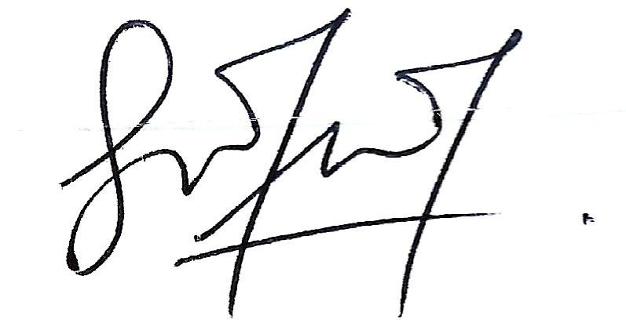
Author Azila Adnan Signature. 
Author _________________________________ Signature __________________________
Author _________________________________ Signature __________________________
Author _________________________________ Signature __________________________

